

COUNCIL MEETING

# Meeting Minutes

**EXECUTIVE COMMITTEE**

# Monday, 26th November 2018 at The Fox Inn

## Attendees

William Elliott (Chairman), Laura Goldsmith (Vice Chairman), Barry Shaw (Treasurer), Grant Pearman, Mike Stocker,

## Apologies for absence

## John James, Peter Knight, Beverley Smith

## To Consider the Minutes of the ExCo meeting held on 10th September 2018

## William Elliott signed the minutes as a true record of the meetings.

1. **Matters arising from the Minutes**

Barhatch Road matter – a chasing letter has been sent as no response to date.

1. **Correspondence**

None relevant.

1. **Treasurers Report**

**Cash**

Cash balances at the end of October were £7.6k lower than at the end of October last year. This is roughly reflective of the loss for the year.

**Full Year Performance**

Income

Income for the year was be £20.0k behind last year and £20.5k behind budget as set out in the previous meeting.

Set out below are details as to which categories are up/down compared last year.

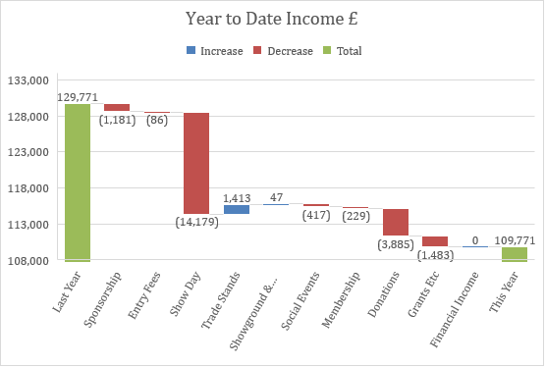

Expenditure

Total costs are down approx. £0.7k on budget and down £7.7k on last year.

Cost variances for the year to date are set out below.

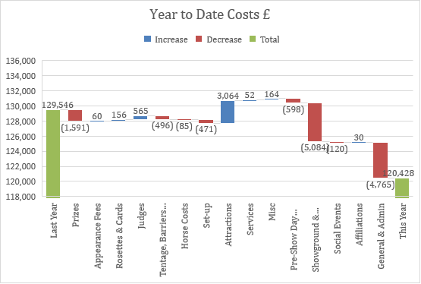

**Summary Surplus & Deficit for 12 months to October 2018**



Anticipated loss for 2018 – c. £10.5k

**AG** to draft Chairman’s Report for WE to review.

1. **Matters relating to Cranleigh Show 2019, inc. Marketing & Fundraising** 
   1. Cranleigh Carnival Date – WE reported that he and AG had met with Derek Trawber of the Lions to discuss the possibility of the Lions moving their carnival date. The response had been lukewarm, however Mr Trawber did promise to go back to the Carnival committee with our concerns about the two events happening on the same weekend. **AG** to give the Lions our Show dates for the next 5 years.
   2. Shotter & Byers – **AG** to approach to see how they feel about sponsoring again in 2019.
   3. Sponsorship leads.:-
      1. Harrisons - Charmer Cheese **LG** had spoken to Mr Harrison, they agreed they should be doing something to support the Show – **LG** to continue to chase.
      2. CCM, Ewhurst (servicing of mule) **LG** had tried to agree a deal with CCM to service the mule as a form of sponsorship in exchange for them having their brand on the mule. They had seemed keen, but unfortunately had withdrawn from discussions.
      3. NFU – they have taken an advert in the Show Programme for 2019.
      4. Alfold Mowers – **LG** had approached and they had seemed keen. **LG** to continue to chase.
2. **AGM and Officers of the Society 2019**

The following had kindly agreed to fulfil the following roles for 2019:-

President – AG to check with John James that he is happy to continue. **AG**

Chairman – Laura Goldsmith

Vice Chairman – Mike Stocker

Treasurer – Barry Shaw

Legal Adviser – **LG** to check with Simon Wood that he is happy to continue

New Council Members proposed – Ellie Whitmore

All existing Council Members to be invited to sit once again. **AG**

Grant Pearman stated his intention to remain Showground Manager for a further 5 years. He requested the committee make the review the following:

1. Topper – request to review the decision not to purchase a new topper in 2019. After much discussion, it was agreed for all to keep an eye out for a 6ft rotary topper. The Society tractor is not powerful enough for a flail mower or equivalent.
2. Show personnel matters discussed.
3. Asbestos roof removal of lean to roof. **GP** to obtain 2 or more quotes for the proper removal of the lean to roof to be removed.
4. **A.O.B**
5. Sheep – are currently in the 2 fields used as public car parks on show day. They will stay there until Xmas, then move to 10 acres. Mr Carr is not prepared to erect an electric fence to fence off the public footpath, **GP** agreed to suggest to him that a single line of fencing is erected with the request for walkers to remain to one side.
6. Local Green Space – LG updated the committee that she was planning on attending the next Cranleigh Parish Neighbourhood Plan meeting when the issue of Local Green Space allocation is due to be discussed. This meeting had not been scheduled as yet. It is clear from looking at the minutes of their previous meetings that notwithstanding what we think, they are going to go ahead and put forward the Showground anyway. The plan will go out for consultation and we can then offer our comments. After the consultation process, it will go the inspector.
7. Wood Fair – not happy about the proposed rise in the hire fee. AG to rewrite and explain again that the discount offered in the first year was due to the preparatory works that they needed to undertake in their first year. i.e. work to footpaths etc. A discount is still being offered for the 2019 hire fee.
8. Cranleigh Lions – still outstanding our response to their questions regarding cancellation fees. **AG** to write to them and let them know that the T&C’s for hiring the Showground are currently being reviewed and we will revert back in due course. **LG** is kindly reviewing these.

Date of next meeting: Monday, 25th February 2019