

COUNCIL MEETING

# Meeting Minutes

**EXECUTIVE COMMITTEE**

# Monday, 9th July 2018 at The Fox Inn

## Attendees

William Elliott (Chairman), Laura Goldsmith (Vice Chairman), Barry Shaw (Treasurer), Grant Pearman, Mike Stocker, Beverley Smith, Roger Nash (co-opted).

## Apologies for absence

## John James, Peter Knight

## To Consider the Minutes of the ExCo meeting held on 11th June 2018

## William Elliott signed the minutes as a true record of the meetings.

1. **Matters arising from the Minutes**

Q. How many wheelbarrows entered the Wheelbarrow Garden Competition? A. 3 – not to be run again in 2019

1. **Cranleigh Show Review 2018**

Livestock

Mike Stocker confirmed that the cattle section ran smoothly and overall the livestock section went well. The heat was an issue and a decision to have a reduced Grand Parade was made. Dexter Cattle exhibitors – some mentioned that the bar to tie the animals up to was too high for Dexters. 2019 GP to include a lower one for Dexter competitors when penning map is done. **MS/GP** Sheep section – personnel issues due to 2 key stewards dropping out last minute which left the other stewards over-stretched. More general sheep stewards required for 2019, not just ring stewards. It is a very large section to manage. **LG** to approach Small Shepherds to ask if any willing stewards. Can a trailer be provided at each end of barn? **MS/GP**

Horses:

A subcommittee of the horse committee met the week of the show to discuss points. Majority of the day went very well. The layout was improved with the jumping rings and collecting ring being bigger this year. Good paid personnel. 480 competitors entered. Seating/bales needed for Rings 5&6 in 2019. **RN/GP**

Ground team:

Roger Nash submitted a written report to the committee (see file) and summarised as follows: -Set up/down all ran well. New purple entrance seemed to work well. Traders - on the whole no real issues. Obviously heat on the day meant trading down for all, inc. artisan food, some more successful than others. Tractor rides – not as well supported due to less families/children on site. Sight of entrance blocked by fire engines possibly. Pink parking remains chaotic and needs further thought. **2019 – Pink labels to inc. box for all traders to write a mobile number on the front for help with moving cars which block access points or are parked in the wrong place.** **AG** Skips continued to be filled with abundant waste food – although agreed little can be done re. this. Should a Rubbish Policy be mentioned in the Show Programme? This would be Franks (skip providers) policy as they take away all waste. Discussion: Large area in front of Whipley Manor Farm made the Showground look / feel a little empty on this side. To be reviewed for 2019. **RN**

Treasurers Report

**Cash**

Cash balances at the end of June were £7.6k higher than at the end of June last year. This is reflective of trade during the last 12 months. Notably, £5.7k of the increase relates to payments from catering concessions that were received during June 2018, but in 2017 were received in July.

**YTD Performance**

Income

Cumulative income for the 8 months to June is £0.5k behind last year and £6.6k behind budget.

Trade stand income is up approximately £1.5k on budget and £1.3k vs last year with entry fees up by £0.8k on budget (£0.7k vs last year). These figures demonstrate encouraging buy-in from participants in advance of show-day. However, donations and sponsorship combined are down £5.5k on budget and £5.6k on last year due to the lack of a headline sponsor. Showground income is also down £1.6k on budget and last year.

Offsetting the above shortfalls vs lat year is show-day income which is £6.2k ahead of last year (although £1.0k down on budget). However, this is due to catering concession income of £5.7k which was received a month earlier than in 2017

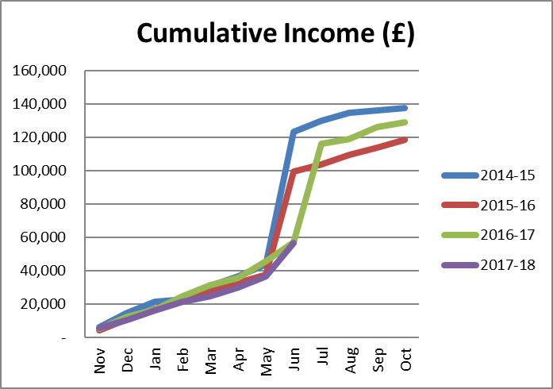

Set out below are details as to which categories are up/down compared last year.

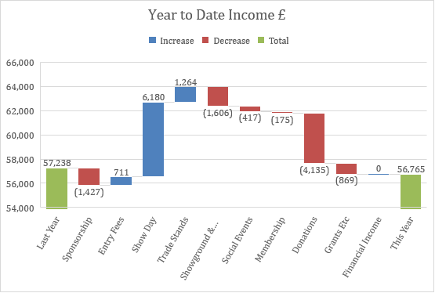

**Expenditure**

Total costs are up approx. £2.7k on budget and up £1.5k on last year.

Show day costs are £1.4k ahead of budget and £2.1k ahead of last year

Mostly timing differences due to St John’s giving £2.1k negative timing variance vs budget and last year), rosettes and prizes (£3.0k negative timing variance vs budget) and tentage giving £0.8k negative variance on budget and £1.0k on last year

Showground and Woodland costs are £1.7k lower than last year and behind budget by £0.6k.

G&A cost savings of £1.3k vs last year are mostly due to printing & stationery efficiencies a previously reported

Cost variances for the year to date are set out below.

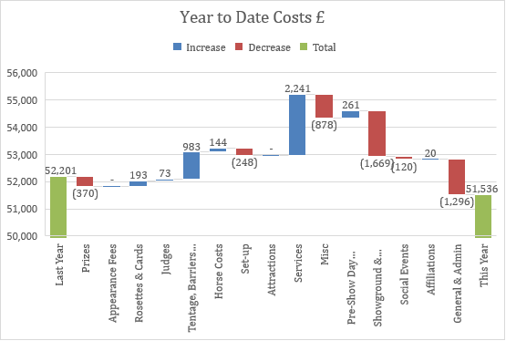

**2018 Show**

Total admissions on the day were disappointing at nearly a third lower than last year. Advance sales were significantly up, which again shows encouraging commitment pre-show – General consensus – the stifling hot day was not going to attract large crowds/families/dogs etc. Temperatures in high 20’s, near 30 degrees by 10am – not good news for numbers! hot weather put people off on the day??***Note – the numbers below reflect only the sales through Bradsons***

We’ve yet to fully process all costs, so final numbers for the show will follow. However, given the gate income above, we are looking at a loss for the full year for between £15k and £20k.

The society has the reserves to be able to manage this loss for this year, but any repeat will start to place a strain on the finances.

Factors which might affect the 2019 Show (Sunday, 30th June 2019) – Cranleigh Carnival set to run the day before again. **AG** to write to Lions and ask them to move their date. No likely, but worth a try.

Other areas of income to be thoroughly explored. Including weddings, horse shows, open air cinema showings, long-term let to a pony club etc. **ALL**

1. **A.O.B**

Mrs Bristow Gate

Welding on the gate was due to take place on 12th June – this will need to be postponed due to no generator available. TWM Solicitors need a reply to their most recent letter. This to be drafted when the welding complete. WE to liaise with the welder re. dates etc and to keep Grant Pearman informed of developments. **WE**

Personnel matters

A number of confidential personnel issues were discussed. Separate records have recorded on these matters as required.

Minutes submitted by: Anna Giller

Approved by: